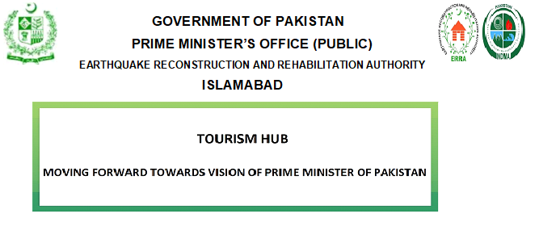

REQUEST FOR PROPOSALS

HIRING OF CONSULTANT FIRMS FOR DETAILED FEASIBILITY STUDY FOR DEVELOPMENT OF NEW BALAKOT CITY DEVELOPMENT PROJECT (NBCDP) AT BAKRIAL, DISTRICT MANSEHRA
AS A TOURISM HUB ON PUBLIC PRIVATE PARTNERSHIP (PPP) MODEL

- Headquarters Earthquake Reconstruction & Rehabilitation Authority (ERRA) intends to carryout Detailed Feasibility Study of NBCDP as a Tourism Hub at Bakrial, District Mansehra on Public Private Partnership (PPP) Mode, in accordance with the Public Private Partnership Authority Act, 2017
- Request for Proposals is required from registered well reputed and highly experienced Consultant Firms to submit/ present Concept Design, Technical Proposal and Financial Bid for Detailed Feasibility Study for development of New Balakot City as Tourism Hub;
- Interested Local, International and Joint Ventures of Local and Foreign Consultant Firms with vast experience in development of mega Tourist Cities, and requisite technical expertise of high quality and financial resources are invited to participate;
- Interested Firms/ JVs must have provided consultancy services on Projects of similar nature of at least PKR 10.00 Bn in last 20 years;
- Selected Consultant Firm will be preparing Detailed Feasibility Study for development of NBC as a Tourism Hub on cost-cum-design basis;
- Bidding shall be conducted on ‘Single Stage Two Envelope’ basis. The name of Bidder and Tender description shall be clearly marked on the envelope for both Technical and Financial Bids separately;
- RFPs having detailed instructions for Consultants can be obtained from the undersigned at a cost of PKR 30,000 (Non Refundable) between 1000 hrs to 1400 hrs from the office of the undersigned within 10 days of this advertisement, but not later than 28th October, 2019;
- The first Pre-bid meeting for addressing the queries will be held at Headquarters ERRA at 1100 Hours on 11th Nov 2019 (Monday)
- Project site visit is mandatory for the participating Consultant Firms. Certificate to this effect shall be issued by ERRA Field Office (NBCDP) at Bakrial which shall form part of technical bid;
- The technical and financial proposals along with all information as per RFP documents are to be submitted (one original and one copy) in sealed cover by 1100 Hours dated 3rd Dec 2019;
- The technical proposals shall be opened by Committee on the same day (3rd Dec 2019) in the presence of Bidders/ Authorized Representatives. Result of Technical Proposals after technical evaluation shall be announced/ conveyed to the participating Firms/ JVs. The date of opening of Financial Bids shall be communicated to the technically successful bidders accordingly, with sufficient notice.

Mirza Khalid Mahmood
Director UD (KP), ERRA
Headquarters ERRA, Room No 412,
Main Murree Road, Islamabad
+92-51-9030965

